**12 BER Performance Analysis** **of various modulation**

**12.1 Objective:**

To analyze the BER performance of Communication System using QAM and 16-QAM scheme using MATLB 2017b.

**12.2 BER Performance analysis of QAM**

**Algorithm:**

1. Initialize the values for number of bit N=10,000, Modulation order M=4 and the signal energy Es=100
2. Assign the Signal constellation points to the variable map
3. Convert the SNR in dB to SNR in linear Scale using appropriate formula
4. Calculate the noise power σ=
5. The bits to be transmitted are randomly generated and mapped to the signal constellation points.
6. At the receiver the Euclidean distance between the received symbol and points on the symbol map is calculated
7. The symbol with minimum distance is chosen and is detected at the receiver
8. The Detected bits are compared with the transmitted bit and Simulated BER is calculated which is number of bits in error to the total number of bits transmitted
9. Steps 3 to 8 is performed for varying SNR (dB) (0 to 20 db)
10. BER versus SNR graph plotted.

**12.2.1 Simulation Flow Diagram:**

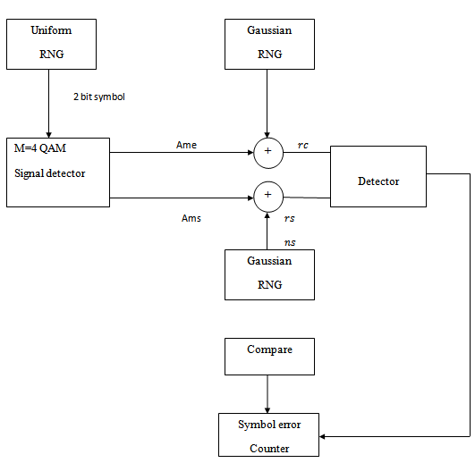

**Fig 12.1 Flow diagram explaining the Simulation of Communication System using QAM Scheme**

**12.2.2 Program:**

% BER performance analysis of QAM Scheme

clc;

clear all;

close all;

% Scatter Plot for QAM points

M = 4;

x = (0:M-1)';

w = qammod(x,M);

scatterplot(w)

% Input data

N=10000;

M=4;

Es=100;

snr_dB=1:21;

% Mapping to Signal Constellation Points

map=[-1,-1;

1,-1;

-1,1;

1,1];

for a=1:21

snr(a)=10^(snr_dB(a)/10);

sigma(a)=sqrt(Es/(4*snr(a)));

end

for a=1:21

err=0;

% Generation of data sources

for b=1:N

temp=rand;

data(b)=1+floor(M*abs(temp));

sign(b,:)=map(data(b),:);

n=sigma(a)*randn(1,2);

rec(b,:)=sign(b,:)+n;

for c=1:M

x=map(c,:);

y=rec(b,:);

dist(c)=sqrt(((x(1)-y(1))^2)-((x(2)-y(2))^2));

% detection

if c==1

dmin=dist(c);

else

dmin=min(dist(c),dmin);

end

if dmin==dist(c)

detect(b)=c;

end

end

if data(b)~=detect(b)

err=err+1;

end

end

BER(a)=err/N;

end

BER

snr_dB=1:21;

figure(2);

semilogy(snr_dB,BER,'-*');

grid on

xlabel('SNR');

ylabel('BER');

title('BER performance analysis of QAM Modulation Scheme');

**12.2.3 Outputs:**

BER= 0.7062 0.6848 0.6872 0.6828 0.6591 0.6420 0.6328 0.6074 0.5815 0.5494 0.5091 0.4649 0.4233 0.3656 0.3053 0.2494 0.1948 0.1272 0.0883 0.0526 0.0301

 

**12.3 BER Performance analysis of 16-QAM**

**Algorithm:**

1. Initialize the values for number of bit N=10,000, Modulation order M=16 and the signal energy Es=100
2. Assign the Signal constellation points to the variable map
3. Convert the SNR in dB to SNR in linear Scale using appropriate formula
4. Calculate the noise power σ=
5. The bits to be transmitted are randomly generated and mapped to the signal constellation point.
6. At the receiver the Euclidean distance between the received symbol and points on the symbol map is calculated
7. The symbol with minimum distance is chosen and is detected at the receiver
8. The Detected bits are compared with the transmitted bit and Simulated BER is calculated which is number of bits in error to the total number of bits transmitted
9. Steps 3 to 8 is performed for varying SNR (dB) (0 to 20 db)
10. BER versus SNR graph plotted.

**12.3.1 Simulation Flow Diagram:**

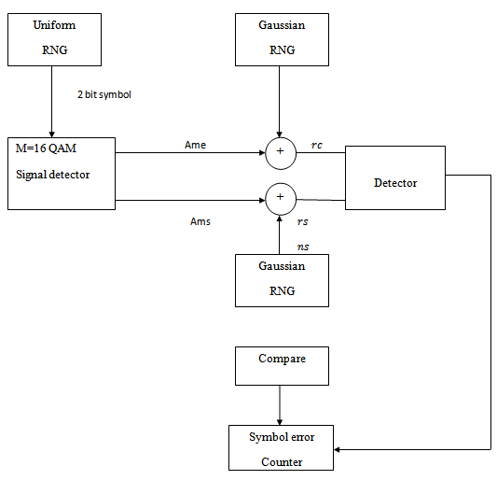

**Fig 12.2 Flow diagram explaining the Simulation of Communication System using 16-QAM Scheme**

**12.3.2 Program:**

BER performance analysis of 16-QAM Scheme

clc;

clear all;

close all;

% Scatter Plot for 16 QAM points

M = 16;

x = (0:M-1)';

w = qammod(x,M);

scatterplot(w)

% Input data

N=10000;

M=16;

Es=100;

snr_dB=1:21;

% Mapping to Signal Constellation Points

map=[-3,3;

-1 3;

1 3

3 3;

-3,1;

-1 1;

1 1;

3 1;

-3 -1;

-1 -1;

1 -1;

3 -1;

-3 -3;

-1 -3;

1 -3;

3 -3];

for a=1:21

snr(a)=10^(snr_dB(a)/10);

sigma(a)=sqrt(Es/(8*snr(a)));

end

for a=1:21

err=0;

% Generation of data sources

for b=1:N

temp=rand;

data(b)=1+floor(M*abs(temp));

sign(b,:)=map(data(b),:);

n=sigma(a)*randn(1,2);

rec(b,:)=sign(b,:)+n;

for c=1:M

x=map(c,:);

y=rec(b,:);

dist(c)=sqrt(((x(1)-y(1))^2)-((x(2)-y(2))^2));

% detection

if c==1

dmin=dist(c);

else

dmin=min(dist(c),dmin);

end

if dmin==dist(c)

detect(b)=c;

end

end

if data(b)~=detect(b)

err=err+1;

end

end

BER(a)=err/N;

end

BER

snr_dB=1:21;

figure(2);

semilogy(snr_dB,BER,'-*');

grid on

xlabel('SNR');

ylabel('BER');

title('BER performance analysis of 16-QAM Modulation Scheme');

**12.3.3 Output:**

BER=0.8474 0.8300 0.8138 0.7881 0.7594 0.7205 0.6810 0.6446 0.5833 0.5273 0.4645 0.3981 0.3107 0.2543 0.1692 0.1159 0.0730 0.0401 0.0196 0.0085 0.0028



**12.4 PRELAB:**

1. What are quad bits?

2. Compute the bit rate for a 1000 baud16-QAM signal

3. In QAM, which parameters of the carrier signal are varied?

**12.5 POSTLAB:**

1. Draw the signal constellation diagram for QAM

2. Compare BPSK, QPSK and QAM in terms of bit rate and bandwidth

**12.6 Result**

Thus the BER performance analysis of communication system using QAM and 16-QAM was performed in MATLAB..